**ASSIGNMENT 2**

**CSCE 614- 600**

**Homework 2**

**Adil Hamid Malla**

**425008306**

**Part A:**

The simulations were run on the zsim simulator. The implementation for the A3 code is included in the zip file attached as the submission.

Part B.

Prediction Accuracy Plot of two predictors A2 and A3

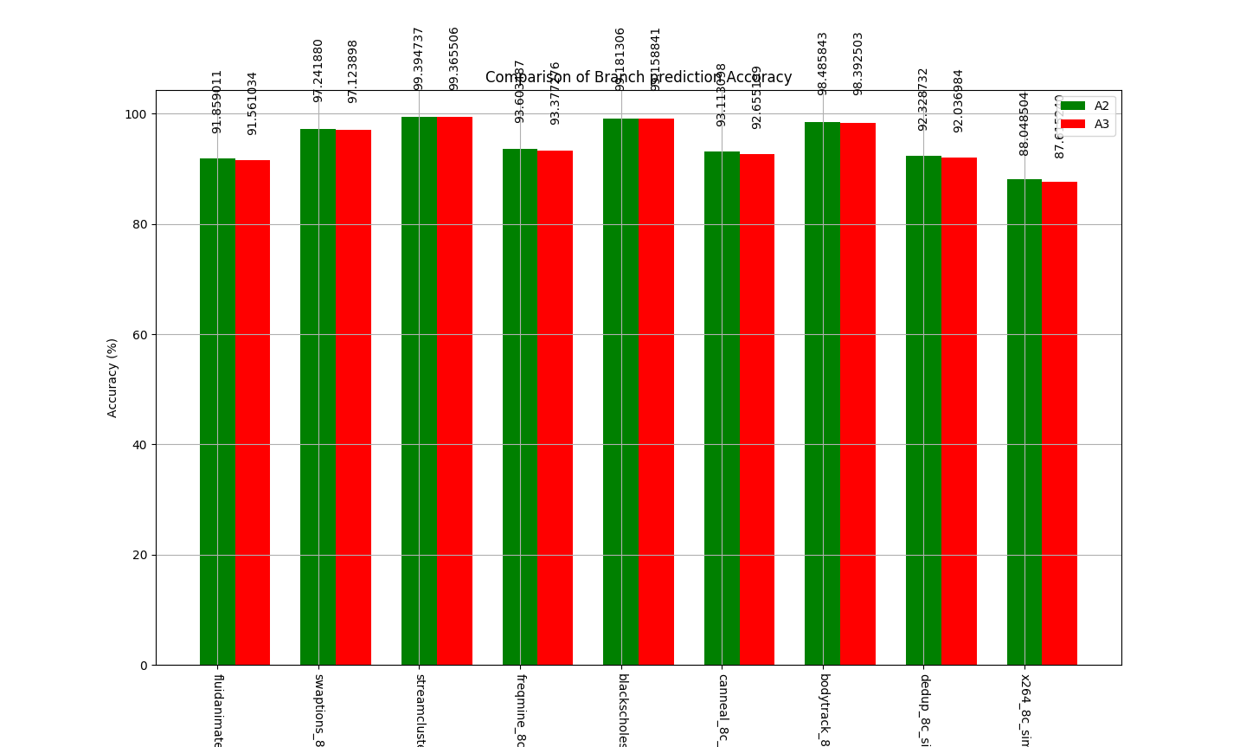

This graph represents the comparison of the A2 and A3 automaton’s prediction accuracy on different benchmarks. As evident from the graphs, the A2 and A3 are very similar in their prediction accuracy. Although the A2 automaton is doing little better as compared to A3.

Also, we noticed that few of the benchmarks prediction accuracy reached as high as 98%, and others reached a level of 88%. When I checked the cycles for the corresponding benchmarks, it reflected that ratio of number of total simulated instructions to that of cycles loosely represents whether a benchmark contains more floating point operations or integer operations. Thus reflecting that the higher prediction rates for the benchmarks represent that the benchmark contains more FP operations and the ones which has less prediction accuracy majorly has less branch prediction accuracy.

Moreover, the medium through small working sets have resulted in higher prediction which is basically greater than 95%, whereas the ones with high working sets has less than it.

The A3 automaton is just slight variations of the A2, hence reason for the similar prediction accuracy and trend for the benchmarks.

Time Computation time comparison between two runs. One when using A2 and when using A3:

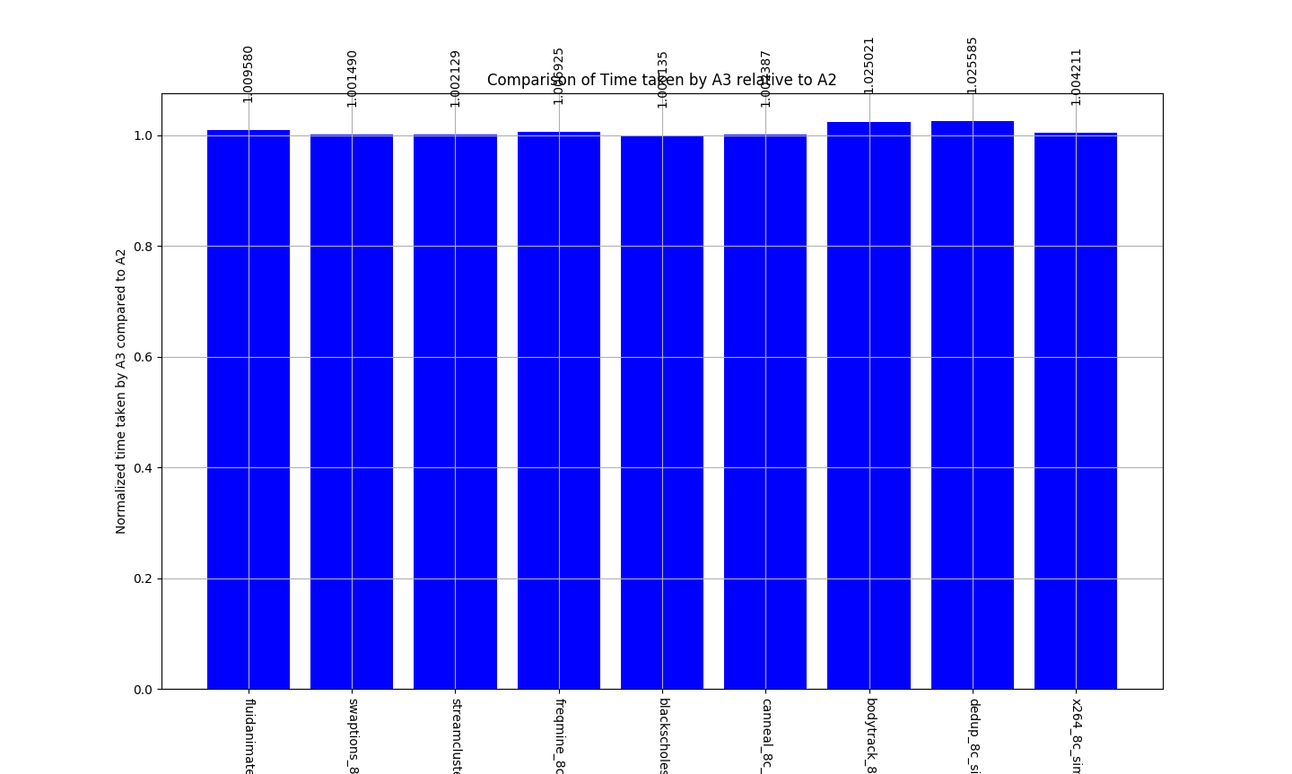

This graph represents the normalized time of the A3 automaton to A2.

All the benchmarks using A3 automaton runs slightly more than as compared to that of the A2 automaton.

The second graph suggests that the time taken by both the automaton is very similar. Again the A2 is performing little bit better as compared to A3 (by very small amount).

As Suggested by the Graphs above, the performance of bit the A2 and A3 Automatons are similar and A2 prediction is little bit on the higher side.

**Part B:**

**For M to be constant for all the cases:**

|  |  |  |  |
| --- | --- | --- | --- |
| **Name** | **N** | **M = 512 for all cases** | **W** |
| **Gag** | 1 | = 2w = 512 | 9 |
| **Gap** | 1 (c = 8) | = C * 2w ‑ = 512 | 6 |
| **PAg** | 8 | = 2w = 512 | 9 |
| **Pap** | 8 (N = 8) | = N * 2w = 512 | 6 |